Git & IntelliJ Assignment

1. **What is the use of the git add command?**

Git add command allows us to stage the individual files or all files in the directory at once, adding them to the staging area(index) in preparation of commit.

* + - git add . --- adds all changes in the current directory
    - git add index.html --- adds a html file(single file)

1. **Write the command to create a branch “feature-group”.**

git branch feature-group

1. **What is a pull request? Write the steps involved in creating a pull request.**

A pull request is a way to request the changes that are made in one branch(feature) be merged into another(main branch).

* + - Push branch to GitHub
    - Go to the repo on GitHub
    - Click “Compare & pull request”
    - Add description/title and click “create pull request”

1. **How do you add collaborators?**

Go to git repo -> settings ->collaborators -> Add people -> Search by username, full name, or email -> Add to repository

1. **What is the command used to commit our changes in github repo?**

git commit –m “Commit Message”

1. **Create a github account and repository to save all your assignment tasks. Example repository name: rg-assignments**

Create a guthub account at <https://github.com> and create a repository name rg-assignments by clicking on create repository.

1. **Create a branch called feature-java(you can use it later to push all your java related tasks to this branch)**

git branch feature-java

1. **Install IntelliJ IDE. Create a simple java project displaying “Hello World!!”and share the screenshot.**

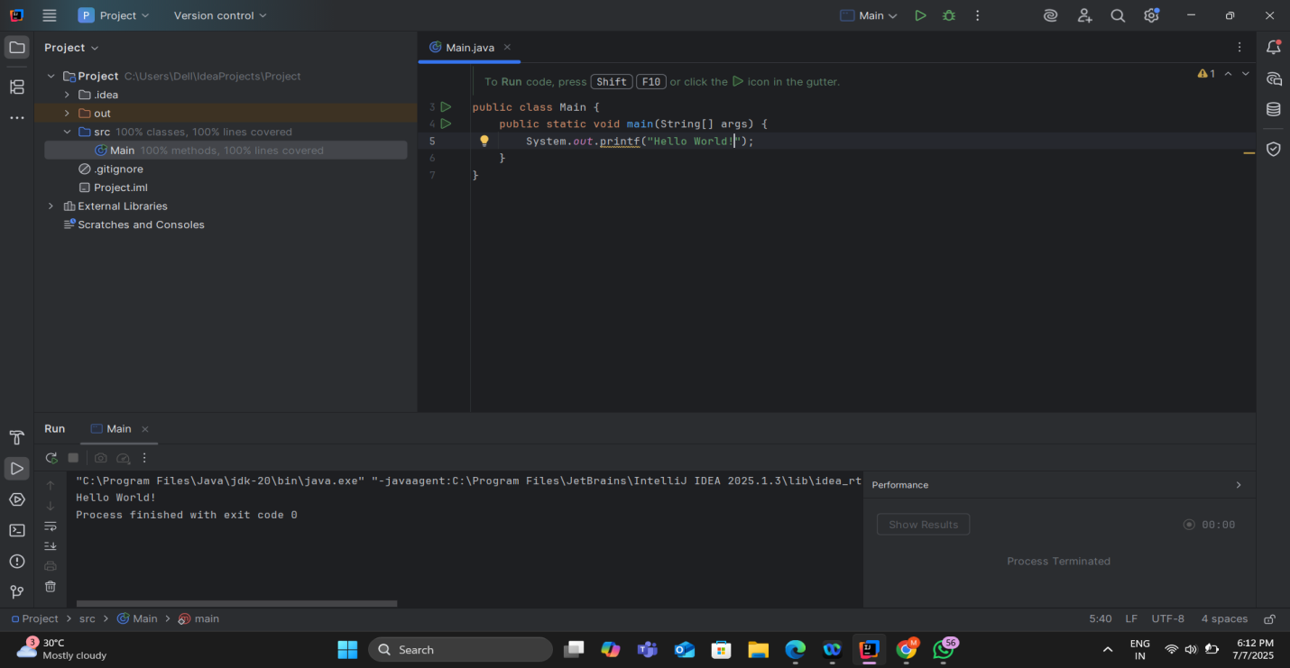

9. **In IntelliJ IDE, explore the shortcut keys for the following**

To run the project: Shift + F10

To select a line: Home then Shift + End

To comment/uncomment a line: Ctrl + /

To delete a line: Ctrl + Y